Virtusa React Training

B Sahil (221910304005)

Day 3

Two types of components

1. Functional Component
2. Class Component

Functional Component Syntax: -

Function User() {

return (

<h1>Welcome too GITAM</h1>

)

}

Export default User;

Class Component Syntax

Import React,{component}

From ‘react’;

Function User extends component

{

Render() {

Return(

<h1>Welcome to GITAM</h1>

)}

Assignment:

Q1. Create a class component called "GITAM", that class Component needs to print "WELCOME TO GITAM". Export that class component to App.js and execute the program

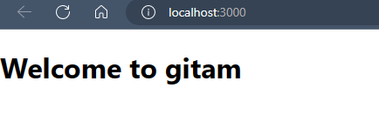

**GItam1.js**

import React, { Component } from 'react'

export default class GItam1 extends Component {

  render() {

    return (

      <div>

        <h1>Welcome to gitam</h1>

      </div>

    )

  }

}

**App.js**

import React from 'react'

import GItam1 from './GItam1';

export default function App() {

  return (

    <div>

      <GItam1/>

    </div>

  )

}

Q2. In App.js, inside the App function, create one function called Banana and it need to return your name. Create a button called Click Banana, whenever Click Banana is clicked, the function should be called.

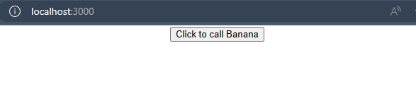

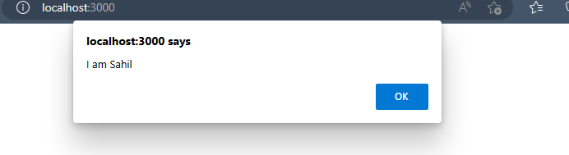

App.js

import React from 'react'

export default function App() {

  function Banana(){

    alert("I am Sahil")

  }

  return (

    <div>

      <center>

       <button onClick={Banana}>Click to call Banana</button>

      </center>

    </div>

  )

}

Q3. In App.js, create a variable item, pass the value UNIVERSITY to that variable and print the value of that variable to the output screen two times by using the variable.

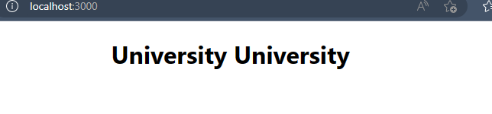

**App.js**

import React from 'react'

export default function App() {

  var item='University';

  return (

    <div>

      <center>

       <h1>{(item+" ").repeat(2)}</h1>

      </center>

    </div>

  )

}